Report: Remote Control Car Teardown
Wireless Mesh Network
Peter Fyon 100652096
peter.fyon@gmail.com

1.0 Introduction
The purpose of this paper is to report on our findings from tearing down one skid-steer (SS) and one turn-steer (TS) remote control car. The report will cover the method used in taking apart the vehicles, the hardware at a general level, and the important lessons learned from the process.

2.0 Method
The deconstruction of each vehicle was simple. The plastic casing was removed with a Phillips head screwdriver to expose the control board inside. Tests were performed on the motors by connecting one to a motor port on the handyboard and using a program, written in Interactive C, to vary the rotational speed (using pulse width modulation) of the motor in both directions. It was noted that the LEDs on the board did not dim visibly with motors from either car, and concluded that they were not drawing more current than the board could provide.

3.0 Hardware
See Figure 1: Car Driver Boards in Appendix A: Figures.

3.1 Skid Steer Car
  - Uses a variety of analog components to filter the incoming signal before sending it to the control circuitry
  - Uses two independently controllable motors on each side of the vehicle to control steering and forward/reverse at the same time
  - Motors are supplied approximately 12 volts from eight AA cell batteries.
  - Each motor is driven forwards or backwards with their own H bridge made up of four heat-sunk power transistors.
  - Turning while moving requires fine control of the rotation speed of the motors
  - The car is capable of turning 360˚ while remaining in place

3.2 Turn Steer Car
  - Uses much fewer analog components, and more integrated circuits than the SS car.
  - Uses one motor to drive the rear wheels and one motor to turn the front wheels left or right.
  - Motors are supplied approximately 3 volts from two AA cell batteries.
  - The default position for the front wheels is straight.
  - Turning the front wheels is limited to all left or all right.

Both of the remote control cars use a radio tuned to the same frequency as the transmitter in the controller. Also, both vehicles have a small capacitor shorting the motor's terminals, presumably to filter out high-frequency noise caused by the motors.

4.0 Lessons
We learned the following things during the deconstruction of this vehicle:
- SS vehicles are less precise in their steering than TS vehicles as the rate of turn is related to the friction between each drive wheel and the ground. The friction may not be the same for each wheel due to different ground materials, differing wear on each wheel, etc.
- The motors are simple to control with pulse width modulation (PWM), and can be driven directly from the Handyboard without additional circuitry.
- The turn angle for our TS vehicle can be made more precise by replacing the motor responsible for turning with a servo and some modifications with the gearing ratio between the servo and the axle.
- Both controllers used simple microswitches to detect forward/reverse and left/right directives from the controller.

These lessons may influence the design for our controller and steering.
Appendix A: Figures
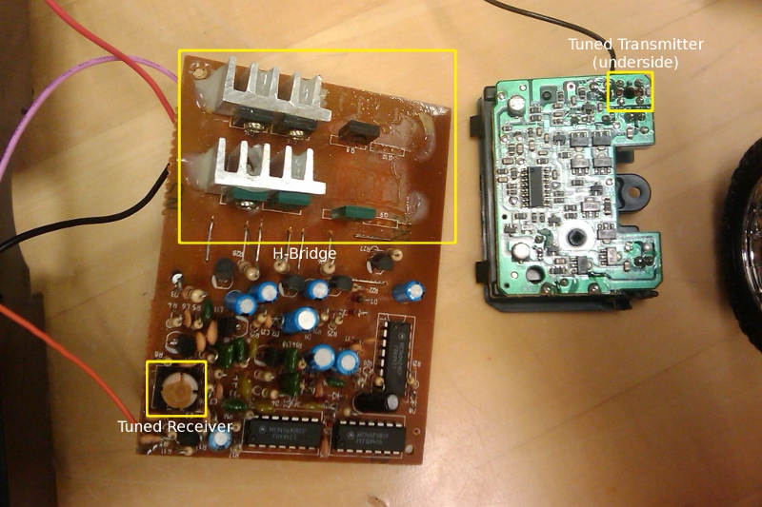Figure 1: Car Driver Boards. Skid steering car on left, turn steering car on right. Note that two power transistors and two heatsinks were removed from the skid steering car board.

